

Lab 2.1: C Libraries, Linking, and ELF Executable Structure

Samjhana Dahal
Bsc (Hons) Computer Science with Artificial Intelligence
Softwarica College of IT and E-commerce ST5003CMD
Operating Systems, Security, and Networks
Rupak Rajbanshi
10th October 4, 2026

Table Of Contents
1. Creating the C Source File 1
2. Displaying the Source Code 2
3. Compiling the Dynamic Program 3
4. Running the Dynamic Program 3
5. Checking Standard Header Files 3
6. Searching Functions in Header Files 4
7. Locating C Libraries 4
8. Creating a Static Executable 5
9. Running the Static Executable 5
10. Identifying Executable Types 6
11. Examining the ELF Header 6
12. Examining Program Headers 7
13. Checking the Dynamic Linker 8
14. Checking Dynamic Library Dependencies 9
15. Checking Runtime Dependencies 10
16. Finding the C Library Location 10
17. Checking Imported Functions 10

Table of figures
Figure 1: Creating the procinfo.c Source File 2
Figure 2: Displaying the C Source Code 3
Figure 3: Compiling and Checking the Dynamic Executable 3
Figure 4: Execution of the Dynamic Program 4
Figure 5: Standard C Header File Locations 4
Figure 6: Searching Functions in Header Files 5
Figure 7: Locations of Static and Shared C Libraries 6
Figure 8: Static Compilation and Executable Size Comparison 6
Figure 9: Execution of the Static Program 7
Figure 10: Dynamic and Static Executable Information 7
Figure 11: ELF Header Information 8
Figure 12: ELF Program Headers and Loadable Segments 9
Figure 13: Dynamic Linker Information 10
Figure 14: Dynamic Section and Required Libraries 10
Figure 15: Runtime Library Dependencies 11
Figure 16: Location of the libc.so.6 Library 11
Figure 17:Imported C Library Functions 12

Introduction
This lab explores how C programs use standard libraries, linking methods, and the ELF executable format in Linux. It demonstrates the difference between static and dynamic linking and uses tools such as gcc, file, readelf, and ldd to examine executable structure and library dependencies.

Objectives
To understand the use of C standard libraries and header files.
To compile programs using static and dynamic linking.
To compare static and dynamically linked executables.
To examine ELF headers and program segments.
To identify shared library dependencies using Linux tools.

1. Creating the C Source File
This command opens procinfo.c in the Nano editor. It is used to create and enter the C source code for the program.
Command:
nano procinfo.c
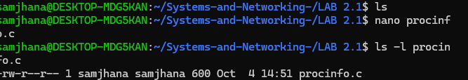
Figure 1: Creating the procinfo.c Source File

2. Displaying the Source Code
This command displays the complete contents of procinfo.c in the terminal. It is used to verify that the source code has been written correctly.
Command:
cat procinfo.c
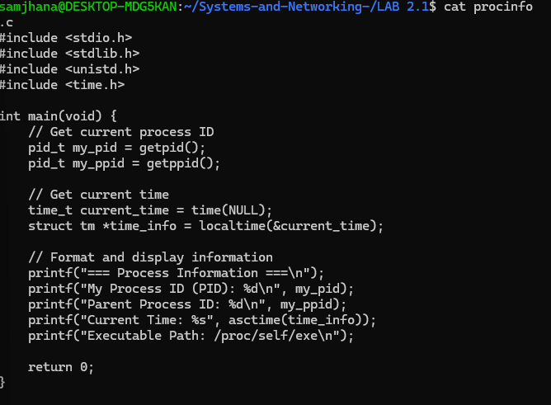
Figure 2: Displaying the C Source Code

3. Compiling the Dynamic Program
This command compiles the C source code using GCC and creates a dynamically linked executable named procinfo_dynamic. The second command checks its file size.
Command:
gcc procinfo.c -o procinfo_dynamic
ls -lh procinfo_dynamic
Figure 3: Compiling and Checking the Dynamic Executable

4. Running the Dynamic Program
This command executes the compiled program. It displays information such as the process ID, parent process ID, current time, and executable path.
Command:
./procinfo_dynamic
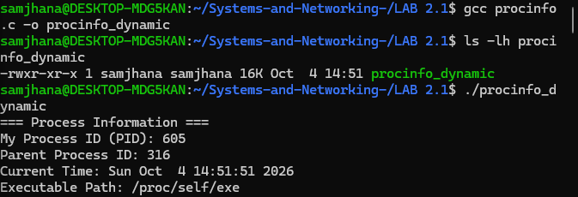
Figure 4: Execution of the Dynamic Program

5. Checking Standard Header Files
These commands check the standard C header files used by the program. They confirm that stdio.h, unistd.h, and time.h are available in /usr/include/.
Command:
ls -l /usr/include/stdio.h
ls -l /usr/include/unistd.h
ls -l /usr/include/time.h
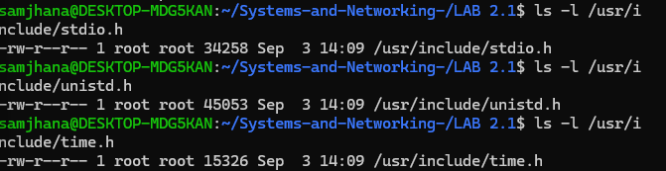
Figure 5: Standard C Header File Locations

6. Searching Functions in Header Files
These commands search the standard header files for functions used by the program, such as printf, getpid, and time.
Command:
grep "printf" /usr/include/stdio.h | head -2
grep "getpid" /usr/include/unistd.h | head -2
grep "time" /usr/include/time.h | head -5
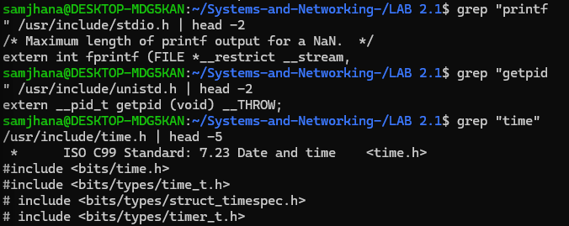
Figure 6: Searching Functions in Header Files

7. Locating C Libraries
These commands locate the shared and static versions of the C standard library. They show where libc.so and libc.a are stored on the system.
Command:
ls -l /lib/x86_64-linux-gnu/libc.so*
ls -l /usr/lib/x86_64-linux-gnu/libc.a
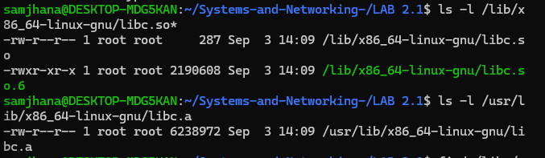
Figure 7: Locations of Static and Shared C Libraries

8. Creating a Static Executable
This command compiles the program using static linking. The required library code is included in the executable, making it larger than the dynamically linked version.
Command:
gcc -static procinfo.c -o procinfo_static
ls -lh procinfo_dynamic procinfo_static
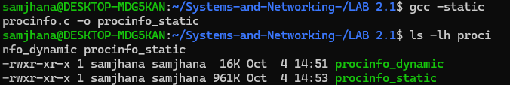
Figure 8: Static Compilation and Executable Size Comparison

9. Running the Static Executable
This command executes the statically linked program. It verifies that the program runs successfully without dynamic library dependencies.
Command:
./procinfo_static
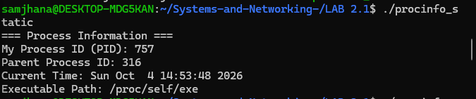
Figure 9: Execution of the Static Program

10. Identifying Executable Types
This command identifies the format and linking type of both executable files. It shows whether each file is dynamically or statically linked.
Command:
file procinfo_dynamic procinfo_staticz
Figure 10: Dynamic and Static Executable Information

11. Examining the ELF Header
These commands display the ELF header information of both executables, including architecture, file type, entry point, and header details.
Command:
readelf -h procinfo_dynamic
readelf -h procinfo_static
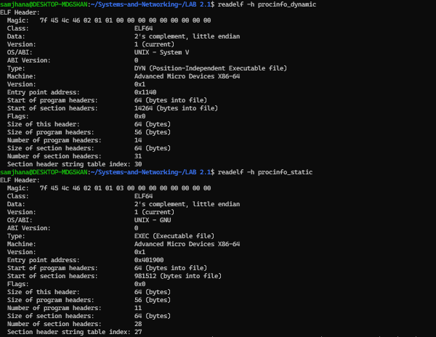
Figure 11: ELF Header Information

12. Examining Program Headers
This command displays the ELF program headers and loadable segments. It helps show how the executable is prepared to be loaded into memory.
Command:
readelf -l procinfo_dynamic
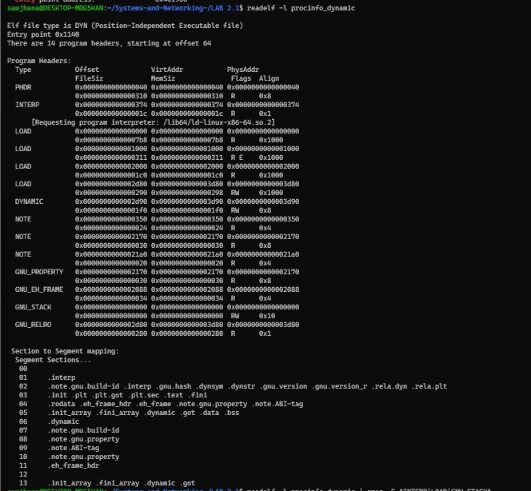
Figure 12: ELF Program Headers and Loadable Segments

13. Checking the Dynamic Linker
This command identifies the dynamic linker requested by the dynamically linked executable during program startup.
Command:
readelf -l procinfo_dynamic | grep "Requesting program interpreter"
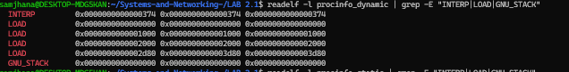
Figure 13: Dynamic Linker Information

14. Checking Dynamic Library Dependencies
These commands examine the dynamic section of the executable and identify the shared libraries required by the program, such as libc.so.6.
Command:
readelf -d procinfo_dynamic
readelf -d procinfo_dynamic | grep NEEDED
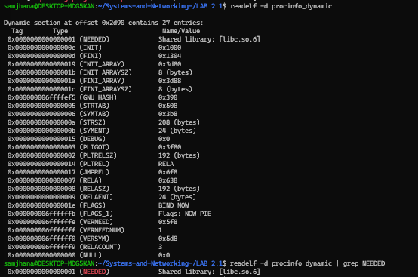
Figure 14: Dynamic Section and Required Libraries

15. Checking Runtime Dependencies
These commands show the shared libraries required by the executables at runtime. The static executable does not have dynamic dependencies.
Command:
ldd procinfo_dynamic
ldd procinfo_static
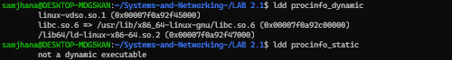
Figure 15: Runtime Library Dependencies

16. Finding the C Library Location
This command searches the system library cache and displays the installed location of libc.so.6.
Command:
ldconfig -p | grep libc.so.6
Figure 16: Location of the libc.so.6 Library

17. Checking Imported Functions
This command displays the external C library functions used by the dynamically linked executable, including printf, getpid, time, and localtime.
Command:
nm -D procinfo_dynamic | grep -E "printf|getpid|getppid|time|localtime|asctime"
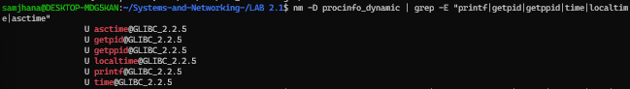
Figure 17:Imported C Library Functions

GitHub Repository:
https://github.com/Samjhanadahal/Systems-and-Networking-.git

